**Module 1: Introduction to C.A.P & Introduction to Cyber Space LESSON PLAN** 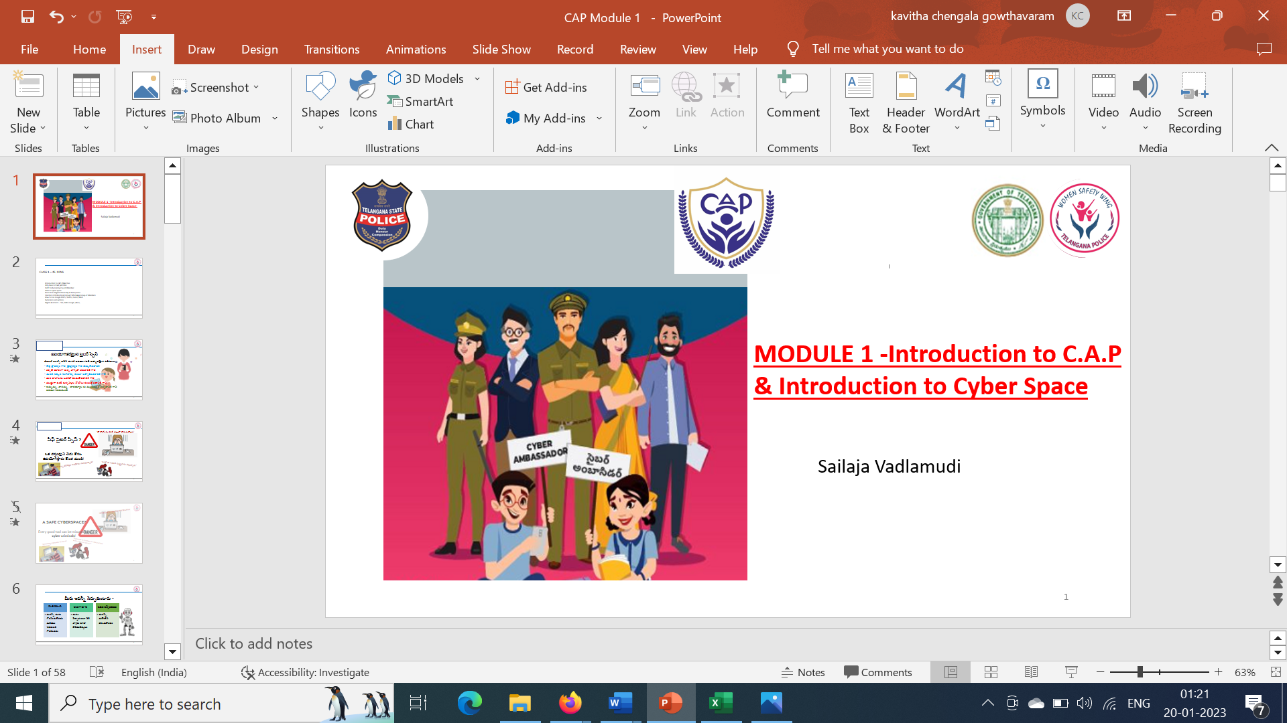

**Learning Outcome**

|  |
| --- |
| On successful completion of the module, learners: |
| **Knowledge :** |
| ·       Appraised on the C.A.P objectives, SHE teams and their role, the need of cyber congress as a protective tool in the digital world, importance of cyber safety for different groups in the community |
| ·       Awareness on the cyber space, basic netiquettes and digital citizenship |
| ·       Understand the different google features like google docs, sheets, forms, meet |
| ·       Identify the Extensions & Add Ons |
| ·       Describe the digital assistants Hello Google , Siri, Alexa and Cortona |
| ·       Discuss the educational app games, external usage devices and websites |
| **Skills :** |
| ·       Collaborate effectively with different stake holders like mentor teachers, trainers, she team officers, officer in charge , volunteer mentors |
| ·       Apply effective oral, written and visual communication skills to create awareness on cyber safety |
| **Application of knowledge and skills :** |
| ·       Apply the skills gained to use the various google features and digital assistants |
| ·       Use the features of google like google docs, sheets, forms, meet for making presentations |

**LESSON PLAN ;**

|  |  |  |
| --- | --- | --- |
| **LESSON NAME /SUBTOPIC** | **MODE /TIME REQUIRED /PPT/ OTHER TEACHING TOOLS** | **EQUIPMENT REQUIRED /ACTIVITY /TIME** |
| Pre assessment | Pre assessment -5 questions (MCQ) to understand the knowledge of the students | **Zoom poll survey -5 min** |
| Creating awareness on the WOMEN SAFETY WING and district SHE TEAM OFFICERS group pic with names of each zone | Group pic of WOMEN SAFETY WING officers and District SHE TEAM OFFICERS pic | **PPT with 2 group pics with names -3 min** |
| Ice breaker - video on CYBER LAB ACTIVITY | Function of cyber lab and the interesting activities that happen in the cyber lab by Sri Harish – Inspector, Cyber lab | **Video – 2.3 min** |
| Ice breaker – Video -case study | Interesting case study narration by Ms Srilekha – women police constable -Karimnagar | **Video – 2.3 min** |
| Introduction to C.A. P | **PPT SLIDES 1 TO 10 SLIDES** | **10 min** |
| C.A.P Objectives |
| Awareness on SHE Teams and how to approach |
| Oath of becoming Cyber Ambassador |
| Need for C.A.P as a tool for protection in the digital world |
| what is Cyber Space |
| Basic rules - Digital Citizen Ship and Netiquettes | **PPT SLIDES 11 TO 19 SLIDES** | **5 min** |
| Creation of Accounts (Google/Gmail/Microsoft account ) | Trainer will open the live google account and demonstrate the activities and features live on screen -**PPT SLIDES 20 TO 57 SLIDES** | **30 min** |
| Usage of Google Features - Google docs  - Sheets - Forms   - Meet |
| Safe browsing -Extensions & Add Ons |
| Digital Assistants- Hello Google, Siri |
| Digital Assistants- Alexa, Cortona | **PPT SLIDE 57** |  |
| Post Assessment explanation | The timeline for completing the post assessment shall be given like an hour from the end of the session. Cyber Ambassador have to log in to the website and answer the questions. There are 10 questions pertaining to the syllabus. | **2 min** |
| Walkathon Narration | Time line to complete this activity is 15 days from the time of completing the first module .Narration given below . | **3 min** |

**PREASSESMENT QUIZ QUESTIONS :**

**Mode : Zoom poll which can give the percentage of yes or no is used to assess the knowledge and experience of students in cyber space**   
**Questions :**

1. Do you use smart phones anytime?

Yes/ No

1. Did you hear the word digital space / cyber space before?

Yes/ No

1. Do you know crimes can happen in cyber space as well?

Yes/ No

1. Have you or anyone in your family or friends been a victim of cybercrimes before like losing money through online links or getting cheated in any form?

Yes/No

1. Do you have an account like Facebook, Instagram, Snapchat?

Yes/No

**POSTASSESMENT QUESTIONS**

1. The acronym T.H.I.N.K mantra used for online safety stands for
2. True, Helpful, Inspiring, Necessary and Kind (ans)
3. True, Hold, Institute, Necessary and Kind
4. Thought, Helpful, Invasive, Need and Kind
5. Thorough, Heavy, Inspiring, Need and Kind
6. Your new online friend has invited you for an ice-cream party. What would be the right response?
7. You would go and meet your friend at the place mentioned by your friend
8. You would deny the invitation (ans)
9. You would take your other friends along with you for the party
10. You would buy a gift for your online friend and then meet him/her
11. You have been browsing and get to see an interesting app which clearly indicates 18 years and above. what should the correct way to deal with this situation?
12. Download it immediately
13. Stay away from the App download (ans)
14. Ask your school friend to help you download
15. Wait for your holidays to download the app
16. You like one of your recent online friends .Your friend asks for your personal pictures and your address .What would you do as a cyber ambassador ?
17. Share the pics and address immediately
18. Will not do that as it is not correct way ( ans)
19. Share only your family pictures
20. Will share your other friends pictures

5.You are doing a project and wanted to check your grammar . You get a message asking you to download the extension tool for the grammar checking ? what would you do ?

a. This extension is for your benefit, so you will add the extension

b. You will not add any extension

c. You will be sure analysing if the extension is safe to add, then only add the extension (ans)

d. You will not bother to do anything

**NOTE ON FIRST ACTIVITY IN CYBER AMBASSADOR PLATFORM (C.A.P)**

**CybHER # Cybersafe For Her**

**ACTIVITY TITLE : WALKATHON TO CREATE AWARENESS ON THE C.A.P program**

**PARTICIPANTS:** Mentor teachers, Cyber Ambassadors , NGO’s pertaining to the immediate community , Volunteer mentors , Important people of the place ( like village sarpanch and other influential people ), or other students from the immediate schools .

**WHEN IS THIS DONE:** After the oath taking session the walkathon shall be finished within 2 weeks’ time

**MODUS OPERANDI:** The participants shall do a walkathon from the school to nearest police station or any notable place of that village / town/city within distance of 1.5 kms carrying the placards, banners or distributing small pamphlets to the people while walking . 2 min creative Skits, songs, poems, dance can be performed on the objective of the C.A.P .

**LANGUAGE for the placards and activities for walkathon** : English or any local language or bilingual as well

**IDEAS THAT CAN BE USED IN THE PROPS FOR THE WALK**

1.We are to protect you in digital space

2.We the Cyber Ambassadors are to help you

3. Cyber space – stay safe

4. Reach us for safe mobile usage

5. We are the cyber Ambassadors -reach out to us for help

**PROPS TO BE USED :** Placards , Small pamphlets or banners , paper masks , crowns etc ( please be as creative as possible )

**AFTER THE WALK :** the schools shall share the pics and videos through google drive or links using the jot form sent

**OUTCOME OF THIS ACTIVITY** : To create awareness on the cyber ambassadors and their help to the community in safeguarding and reporting the cyber crimes